**Table 1: COMPLETE Table, De Jure, De Facto, Overall**

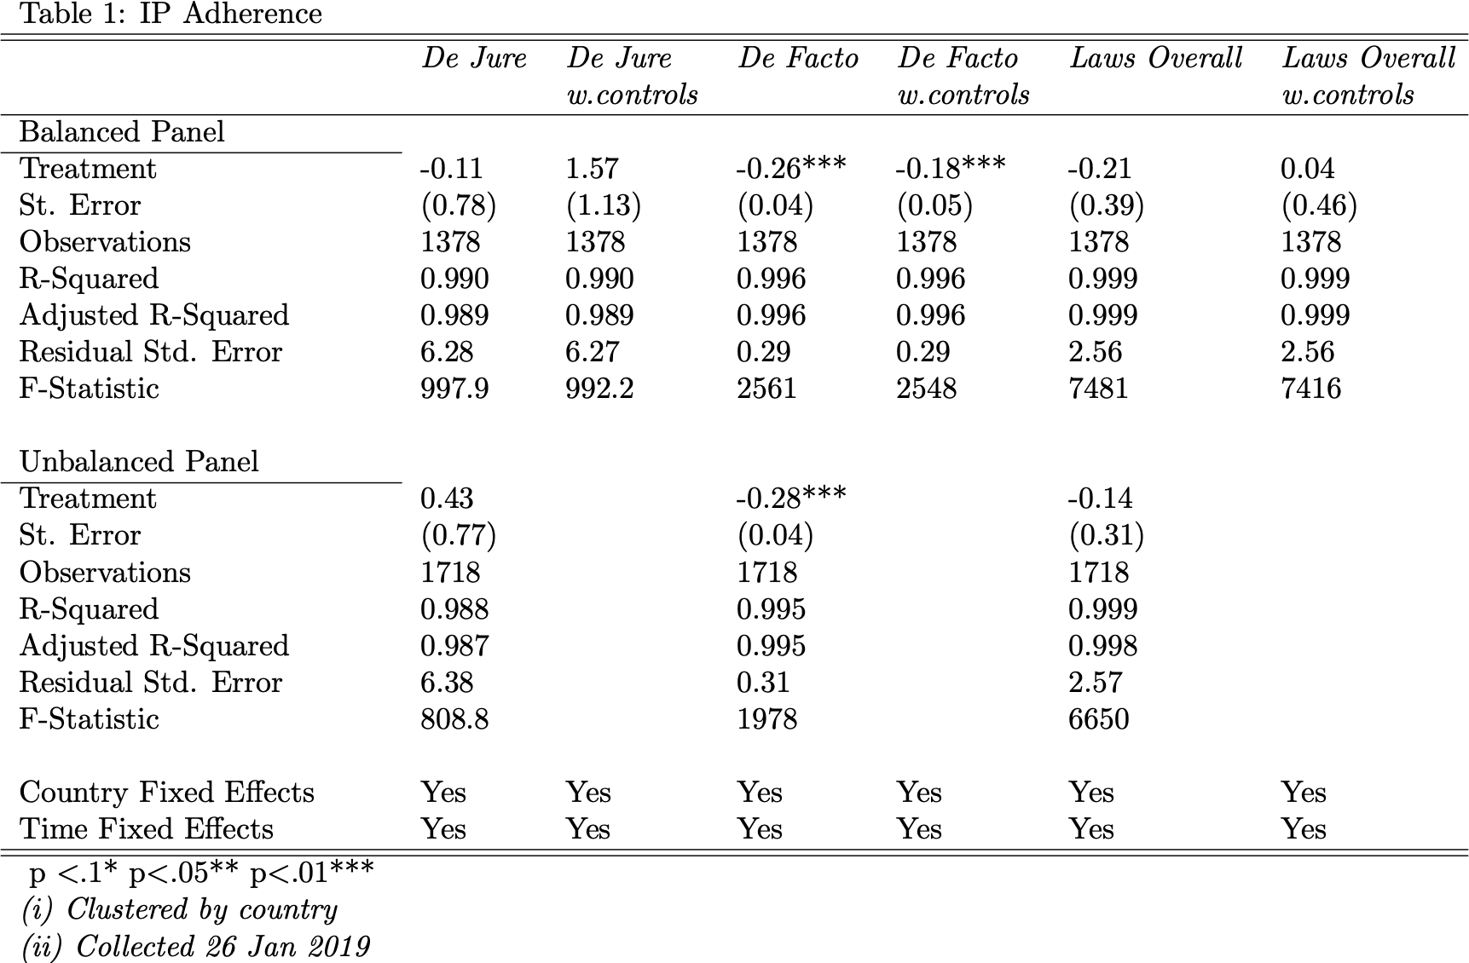

\begin{table}[ht]

\centering

\begin{tabular}{lllllll}

Table 1: IP Adherence \\

\hline

\hline

& \textit{De Jure} & \textit{De Jure} & \textit{De Facto} & \textit{De Facto} & \textit{Laws Overall} & \textit{Laws Overall} \\

& & \textit{w.controls} & & \textit{w.controls} & & \textit{w.controls} \\

\hline

Balanced Panel \\

\cline{1-1}

Treatment & -0.11 & 1.57 & -0.26*** & -0.18*** & -0.21 & 0.04 \\

St. Error & (0.78) & (1.13) & (0.04) & (0.05) & (0.39) & (0.46) \\

Observations & 1378 & 1378 & 1378 & 1378 & 1378 & 1378 \\

R-Squared & 0.990 & 0.990 & 0.996 & 0.996 & 0.999 & 0.999 \\

Adjusted R-Squared & 0.989 & 0.989 & 0.996 & 0.996 & 0.999 & 0.999 \\

Residual Std. Error & 6.28 & 6.27 & 0.29 & 0.29 & 2.56 & 2.56 \\

F-Statistic & 997.9 & 992.2 & 2561 & 2548 & 7481 & 7416 \\

\\

Unbalanced Panel \\

\cline{1-1}

Treatment & 0.43 & & -0.28*** & & -0.14 & \\

St. Error & (0.77) & & (0.04) & & (0.31) & \\

Observations & 1718 & & 1718 & & 1718 & \\

R-Squared & 0.988 & & 0.995 & & 0.999 & \\

Adjusted R-Squared & 0.987 & & 0.995 & & 0.998 & \\

Residual Std. Error & 6.38 & & 0.31 & & 2.57 & \\

F-Statistic & 808.8 & & 1978 & & 6650 & \\

\\

Country Fixed Effects & Yes & Yes & Yes & Yes & Yes & Yes\\

Time Fixed Effects & Yes & Yes & Yes & Yes & Yes & Yes\\

\hline

\hline

\ p \textless .1* p\textless .05** p\textless .01*** \\

\textit{(i) Clustered by country} \\

\textit{(ii) Collected 26 Jan 2019 } \\

\end{tabular}

\end{table}

**Table 1: Total Table Including Non-TRIPS Control**

\begin{table}[ht]

\centering

\begin{tabular}{lcccc}

Table 1: Results \\

\hline

\hline

& & \textit{dependent vars} \\ \cline{2-4}

& (1) & (2) & (3) \\

\hline

Treatment & 0.39* & .40* & .40* \\

& (0.24) & (0.23) & (0.23) \\

\\

Fixed Effects by Country & Yes & Yes & Yes & \\

\\

Fixed Effects by Year & Yes & Yes & Yes & \\

\\

\hline

Observations & 170 & 115 & 115 & \\

R-Squared & 0.991 & 0.989 & 0.989 & \\

Adjusted R-Squared & 0.987 & 0.986 & 0.986 & \\

Residual Std. Error & 0.446 & 0.436 & 0.439 \\

F-Statistic & 282.2 & 303.2 & 335.9 & \\

\hline

\hline

\textit{Note:} p \textless .1* p\textless .05** p\textless .01*** \\

\textit{(i) Cluster by country} \\

\textit{(ii) Data collected Oct 2019 } \\

\end{tabular}

\end{table}

**Table 2: INDIVIDUAL TABLE w/ Non-TRIPS Control**

\begin{table}[ht]

\centering

\begin{tabular}{lcccc}

Table 2: Results by Indicator \\

\hline

\hline

& & \textit{dependent vars} \\ \cline{2-4}

& (1) & (2) & (3) \\

\hline

Total & 0.39* & 40* & .40* \\

& (0.24) & (0.23) & (0.23) \\

Patent Requirements & 0.06 & 0.07 & 0.08 \\

& (0.19) & (0.05) & (0.05) \\

Computer Implemented Inventions & 0.10** & 0.10* & 0.10* \\

& (0.048) & (.06) & (0.06) \\

Pharmaceutical Patent Enforcement & 0.01 & 0.02 & 0.01 \\

& (0.07) & (0.06) & (0.06) \\

Singapore Agreement & 0.07 & 0.08 & 0.09 \\

& (0.08) & (0.06) & (0.06) \\

Patent Law Treaty & 0.06 & 0.06 & 0.06 \\

& (0.06) & (0.07) & (0.07) \\

At Least One International Treaty & -0.03 & -0.03 & -0.03 \\

& (0.09) & (0.1) & (0.1) & \\

Trade Secrets & 0.02 & 0.02 & 0.02 \\

& (0.02) & (0.02) & (0.02) \\

Barriers to Access & 0.09 & 0.09 & 0.08 \\

& (0.09) & (0.10) & (0.09) \\

\\

Fixed Effects by Country & Yes & Yes & Yes \\

\\

Fixed Effects by Year & Yes & Yes & Yes \\

\\

\hline

Observations & 170 & 115 & 115 & \\

R-Squared & 0.991 & 0.989 & 0.989 & \\

Adjusted R-Squared & 0.987 & 0.986 & 0.986 & \\

Residual Std. Error & 0.446 & 0.436 & 0.439 \\

F-Statistic & 282.2 & 303.2 & 335.9 & \\

\hline

\hline

\textit{Note:} p \textless .1* p\textless .05** p\textless .01*** \\

\textit{(i) Cluster by country} \\

\textit{(ii) Data collected Oct 2019 } \\

\end{tabular}

\end{table}

**Table 3: Descriptions of Dispute Settlement Procedure**

\begin{table}[ht]

\centering

\begin{tabular}{rrrrr}

\hline

\textbf{Timeline} & & & & \textbf{Description}\\

\hline

60 Days & & & & Consultations, mediation, etc \\

45 Days & & & & Panel set up and panelists appointed \\

6 Months & & & & Final panel report to parties \\

3 Weeks & & & & Final panel report to WTO members \\

60 Days & & & & Dispute settlement body adopts report (if no appeal) \\

\hline

\textbf{Total: 12 Months (without appeal)} & & & & \\

\\

\hline

60 - 90 Days & & & & Appeals report \\

30 Days & & & & Dispute settlement body adopts appeals report \\

\hline

\textbf{Total: 15 Months (with appeal)} & & & & \\

\\

\hline

\end{tabular}

\end{table}

**Table 4: All Countries in Sample**

\begin{table}[ht]

\centering

\begin{tabular}{lllll}

Table 4: Sample Countries \\

\hline

Algeria & Argentina & Australia & Brazil \\

Brunei & Canada & Chile & China \\

Colombia & Costa Rica & Ecuador & Egypt \\

India & Indonesia & Israel & Japan \\

Jordan & Kenya & Malaysia & Mexico \\

Morocco & New Zealand & Nigeria & Pakistan \\

Peru & Philippines & Saudi Arabia & Russia \\

Singapore & South Africa & South Korea & Switzerland \\

Taiwan & Thailand & Turkey & Ukraine \\

United Arab Emirates & United States & Venezuela & Vietnam \\

\hline

\end{tabular}

\end{table}

**Table 5: Appendix TRIPS Agreement over time 2014-2019**

\begin{table}[ht]

\centering

\begin{tabular}{rrrrrr}

\hline

& 2014 & 2015 & 2017 & 2018 & 2019 \\

\hline

Argentina & 0 & 0 & 0 & 0 & 0\\

Australia & 0 & 0 & 1 & 1 & 1 \\

Brazil & 0 & 3 & 3 & 3 & 3\\

Canada & 2 & 2 & 5 & 7 & 7 \\

Chile & 0 & 0 & 0 & 0 & 0\\

China & 2 & 5 & 7 & 15 & 18\\

Colombia & 0 & 0 & 0 & 0 & 4\\

European Union & 10 & 15 & 17 & 18 & 18\\

India & 0 & 2 & 2 & 3 & 13 \\

Indonesia & 14 & 18 & 18 & 18 & 20\\

Japan & 0 & 0 & 0 & 0 & 5 \\

Malaysia & 0 & 0 & 0 & 0 & 0\\

Mexico & 0 & 0 & 0 & 1 & 1\\

New Zealand & 0 & 0 & 0 & 0 & 0\\

Nigeria & 0 & 0 & 0 & 0 & 0\\

Russia & 1 & 2 & 6 & 7 & 7\\

Singapore & 0 & 0 & 0 & 0 & 0\\

South Africa & 0 & 2 & 2 & 2 & 2\\

Thailand & 0 & 0 & 0 & 0 & 0\\

Turkey & 0 & 0 & 0 & 3 & 6\\

Ukraine & 0 & 2 & 9 & 9 & 9\\

United Arab Emirates & 0 & 0 & 2 & 2 & 2\\

United States & 4 & 6 & 16 & 57 & 64\\

Vietnam & 0 & 0 & 0 & 0 & 0\\

\hline

\end{tabular}

\end{table}

**Table 6: Description of IP Indicators**

\begin{table}[ht]

\centering

\begin{tabular}{rl}

Table 6: Descriptions of IP Indicators \\

\hline

\textbf{Label} & \textbf{Description of Indicator}\\

\hline

\hline

Patent Requirements & The extent to which patentability requirements are in line \\

& with international standards of novelty, inventive step, \\

& and industrial applicability. Measured by (1) existing de \\

& jure patentability guidelines and regulations and (2) de facto \\

& standards established through the application of these \\

& guidelines and regulations through the examination process \\

& and judicial review. This is a mixed indicator. \\

\hline

Computer Implemented Inventions & Measured by the extent to which \\

& primary and/or secondary legislation explicitly allows for the \\

& patentability of computer-implemented inventions. \\

& This is a mixed indicator. \\

\hline

Pharmaceutical Patent Enforcement & Measured by the existence of primary and/or \\

& secondary legislation (such as a regulatory and/or \\

& administrative mechanism) that provides a transparent \\

& pathway for adjudication of patent validity and \\

& infringing issues before the marketing of a generic or \\

& biosimilar product. This score is evenly divided between \\

& the existence of a relevant mechanism and its \\

& application/enforcement. If no mechanism is \\

& in place, the maximum score that can be achieved is \\

& 0.5 and is based on the extent to which defacto \\

& practices (such as expeditious preliminary injunctive relief) \\

& are in place that achieve a similar result. \\

& This is a mixed indicator. \\

\hline

Singapore Agreement & Measured by the extent to which a country takes part \\

& and upholds the Singapore Treaty on the Law of Trademarks. \\

& This is a mixed indicator. \\

\hline

Patent Law Treaty & Measured by the extent to which a country takes part \\

& and upholds the international Patent Law Treaty. \\

& This is a mixed indicator. \\

\hline

At Least One International Treaty & Measured by the extent to which a country takes part \\

& and upholds at least one international treaty. \\

& This is a mixed indicator. \\

\hline

Trade Secrets & Measured by the existence of (1) legislation \\

& that offers protection for trade secrets or confidential \\

& business information and (2) the application of this legislation \\

& in the court or law enforcement system. \\

& This is a mixed indicator. \\

\hline

Barriers to Access & Measured by the extent to which laws and \\

& regulations or de facto practices do not make access to an \\

& economy’s market contingent on the sharing and/or disclosure \\

& of intellectual property and know-how with a local or \\

& domestic entity. This indicator is measured by the extent \\

& to which (1) existing laws and procedures do not make market \\

& access contingent on the sharing or disclosure of intellectual \\

& property and know- how; and (2) the application of such laws \\

& or in the absence of such laws the existence of de facto \\

& practices and standards that achieve a similar effect. \\

& This is a mixed indicator. \\

\hline

\textit{Source: 2019 GIPC International IP Index} \\

\end{tabular}

\end{table}